.

# Lab Exercise 6.2

**Creating a New Jenkins Job to Checkout Source Code**

**Name - Arin Agrawal**

**SapID: 500120660**

**Roll no:R2142230502**



**Step 1: Log in and create a Jenkins job**

* 1. Navigate to **localhost:8080** in your web browser, enter your credentials, and click on **Sign In**



Create a new Jenkins job by clicking on **New Item**

* 1. Provide custom job name inside the field **Enter an item name,** select the **Freestyle project** option, and click on the **OK** button to save the job

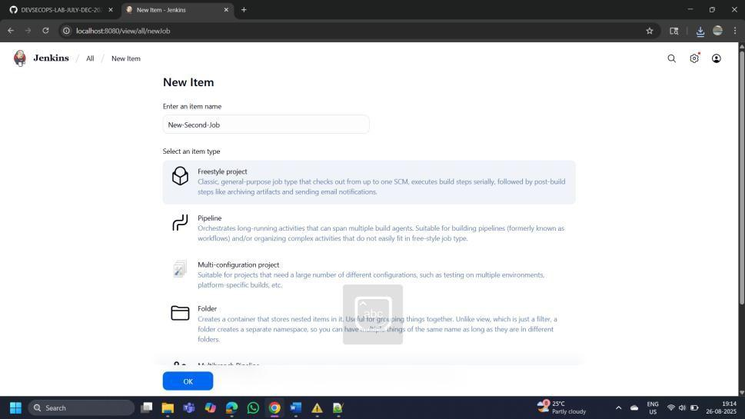

.

## Step 2: Configure source code management

* 1. Access the newly created job's configuration screen by clicking on **Configure**

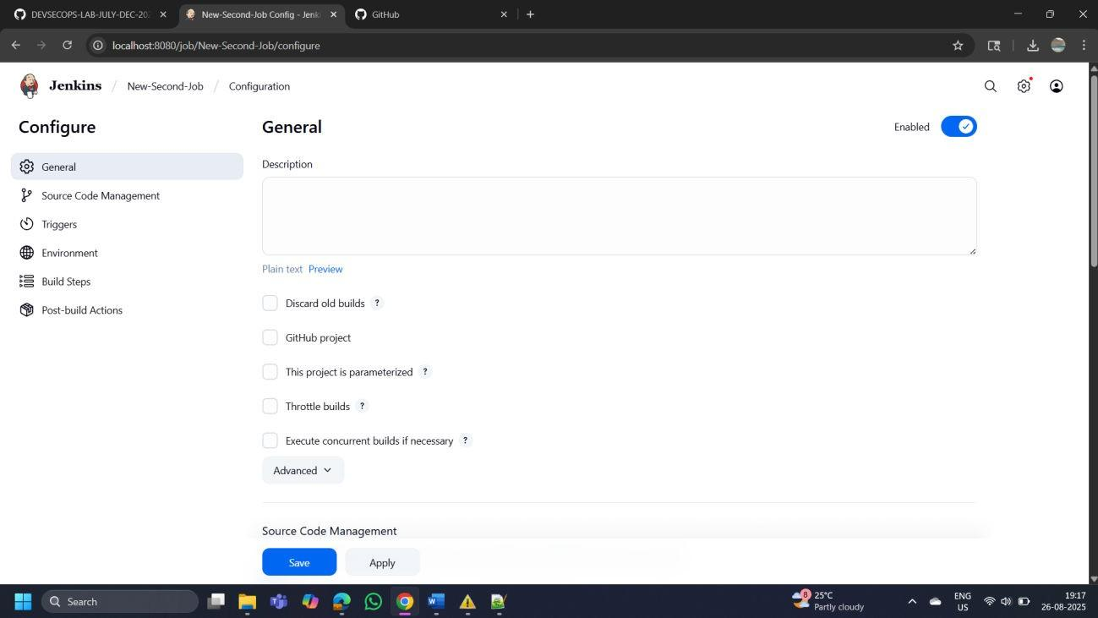

* 1. Navigate to the **Source Code Management** tab, provide Git repository configuration inside the **Repository URL** field, and click on the **Save** button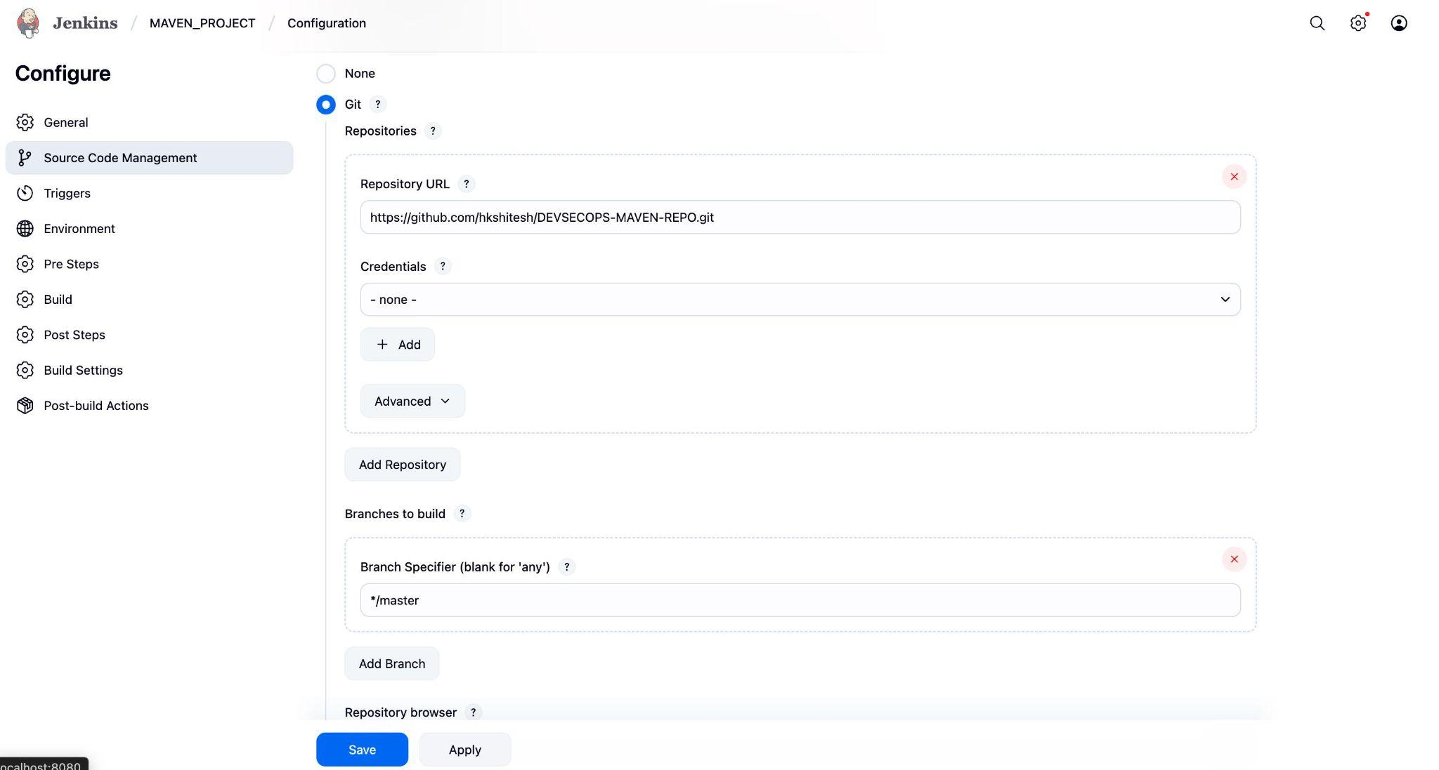
  2. Then, click on the **Build Now** option to schedule a build

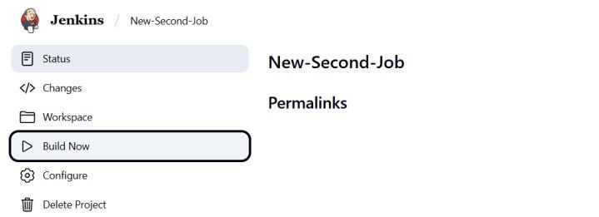

* 1. To schedule the build, click the required link under **Permalinks**

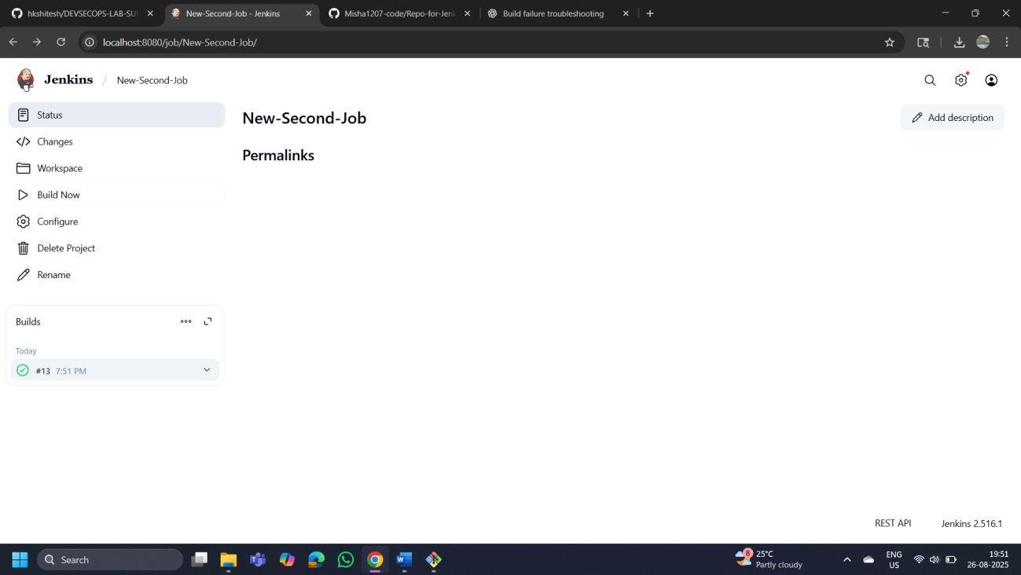

* 1. Click on **Console Output** to check out the process during the build process

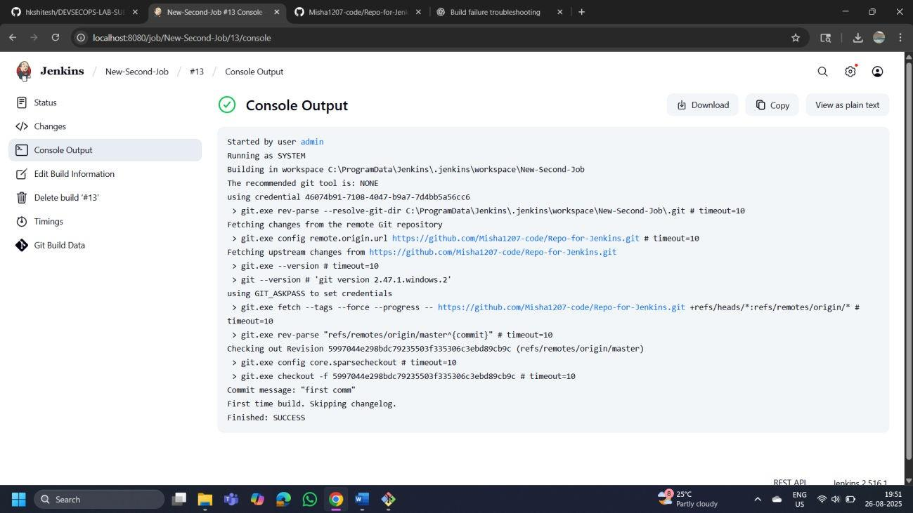

By following these steps, you have successfully set up a Jenkins job to automatically check out source code from a Git repository, enabling seamless integration and automation in your CI/CD pipeline.